Instructions for Micro Services Lab Test
- Check the working status of the following:
  - phpmyadmin (URL on browser http://locahost)
  - docker info (check for IP 172.1.14.168:5001)
  - kubectl get nodes (csegpuserver with Ready STATUS)
  - postman
- Create a folder by your USN
For Kubernetes Program
- Create namespace by your USN
- Type dep.yaml inside the USN Folder
For Spring Boot Program
- Create a database as per the question given
- Type URL 172.1.14.200:81/mslabsw
- Download
  - m2.zip (This is a repository of required dependencies)
  - mslab-srpingboot-test.zip (This is a demo skeleton code)
- Copy both zipped folder to the USN folder (step-2)
- Double-click the zipped folder to extract it. (Do not right-click & Extract here)
- The files will be extracted as .m2 and mslab-srpingboot-test in “USN folder”
- Open Intellij IDE
- If any Project is Opened. Close the Project.
- Open project mslab-Demo1 from the USN folder
- Change path to Dependency Repository
  - File -> Setting -> Build, Execution, Deployment -> Build Tools -> Maven
  - Change Local Repository path to /home/lab/USN/.m2/repository
by checking Override button.
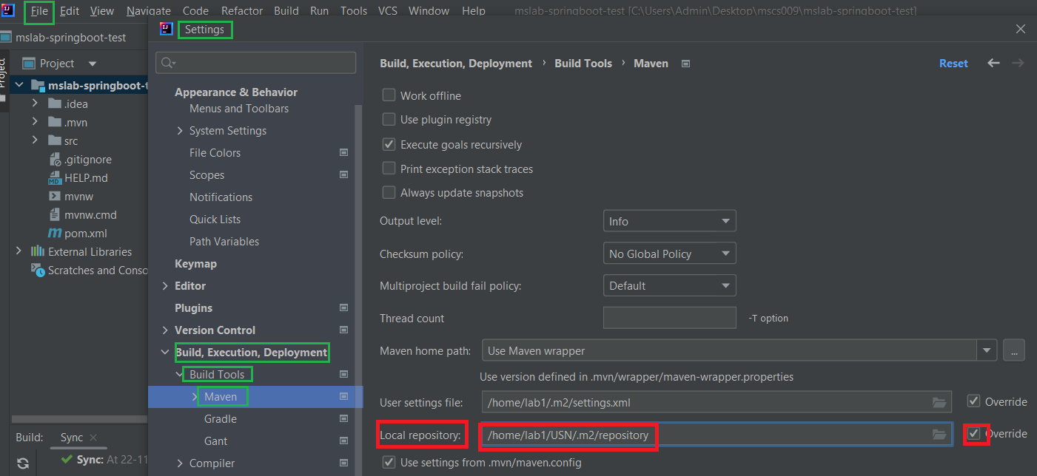

- Immediately after completing the test, remove the USN folder without fail.

